Home

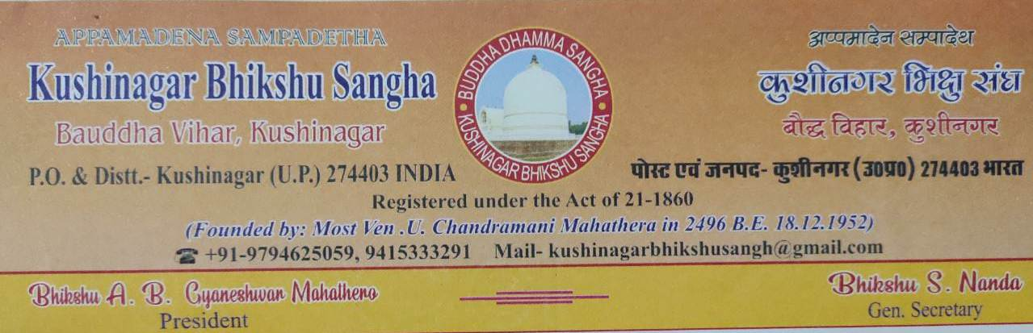

Handa dāni, bhikkhave, āmantayāmi vo vayadhammā saṅkhārā appamādena sampādethā’ti.
Behold, O disciples, I exhort you. Subject to decay are all component things. Achieve all your duties with heedfulness.

About

About us:
Kushinagar Bhikshu Sangha is a well known society of Kushinagar, the mahāparinabbāna place of Gautam Buddha. On 18th December 1952, it was established by Ven. Bhikhsu U. Chandramani Mahasthavir, the dhamma master of Baba Saheb Dr. B.R. Ambedkar. This registered society is working for the upliftment of Kushinagar and the development of Buddhism as well as education, health, and society since 1952. Kushinagar Bhikshu Sangha is a charitable and non-profit Buddhist organization. It is dedicated to fulfill the mission and vision of Ven. Bhikhsu U. Chandramani Mahasthavir so that the teachings of Gautam Buddha could be spread for the welfare of all beings without any discrimination of caste, coulour, belief, religion, nationality etc.

About Founder:
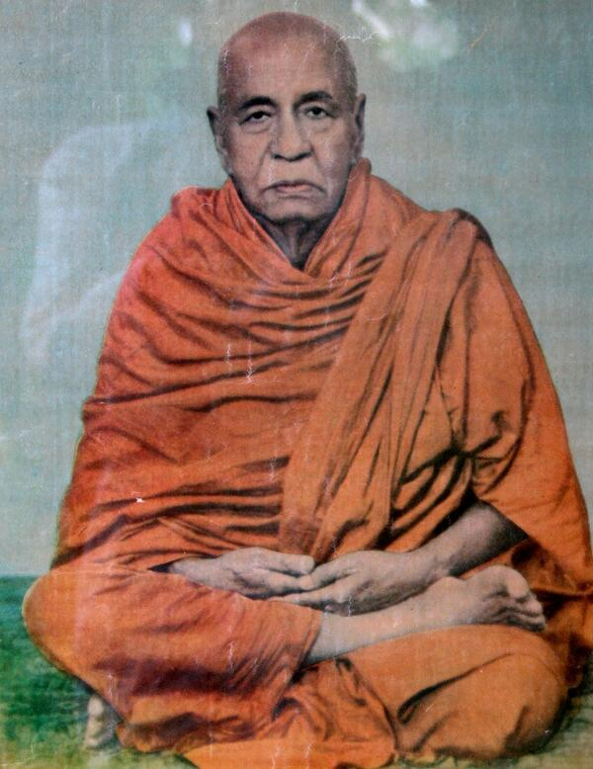

The most venerable Bhikshu U. Chandramani Mahasthavir is considered as the main contributer in the upliftment of Kushinagar, and has a very prominent role in the revival of Buddhism in India in 20th century. He was born on Tuesday of the 6 Jyesthvadi (Jyeshtha or Jyēṣṭha) of 1876 A.D. in Myanmar. After getting his primary education, he was ordained by Bhikshu U. Candimā in 1888 A.D., and the name ‘Candā’ was given to him who became famous as Bhikshu U. Chandramani Mahasthavir later. Bodhisattava Anagārika Dharmapāla, the founder of the Maha Bodhi Society of India, brought him to India. He started to stay in Buddhagaya, and also studied in Calcutta. Due to some problems, he returned to Arakan. Again, he came back to India, and met the most Bhadant Mahavir Mahasthavir. In 1903 A.D., he got high ordination, and made Kushinagar as his permanent residence and work place. Bhikshu U. Chandramani Mahasthavir’s three disciples like Bhikshu Buddharakshit, Bhikshu Dharmarakshit, and Bhikshu Sangharakshita (Urgen Sangharakshita) achieved good name & fame in the Buddhist world, and contributed in the revival of Buddhism as well as development of Buddhist literarure. He sacrificed his entire life for upliftment of Kushinagar as well as the propagation of Buddhism in India & abroad. He established Kushinagar Bhikshu Sangha, Kushinagar on December 18, 1952. He passed away at Kusīnārā Sīmā situated in Myanmar Buddhist Temple, Kushinagar at 9.45 A.M. on 8th May 1972. After his departure, his disciple Aggamahapandita Bhadant Gyaneshwar Mahasthavir, the President of Kushinagar Bhikshu Sangha, Kushinagar and Chief Abbot of Myanmar Buddhist Temple, Kushinagar is moving ahead on the mission and vision of Bhikshu U. Chandramani Mahasthavir.
Office Bearers:


President
Aggamahapandita Bhadant Gyaneshwar,
Myanmar Buddhist Temple, Buddhanagari, Kushinagar,
Post & District: Kushinagar, Uttar Pradesh (India)
Contact no.: +91-9794625059

Vice-President
Bhikshu Wannadhaja Mahathera,
Myanmar Buddha Vihara,
Sarnath, Varanasi, Uttar Pradesh (India)

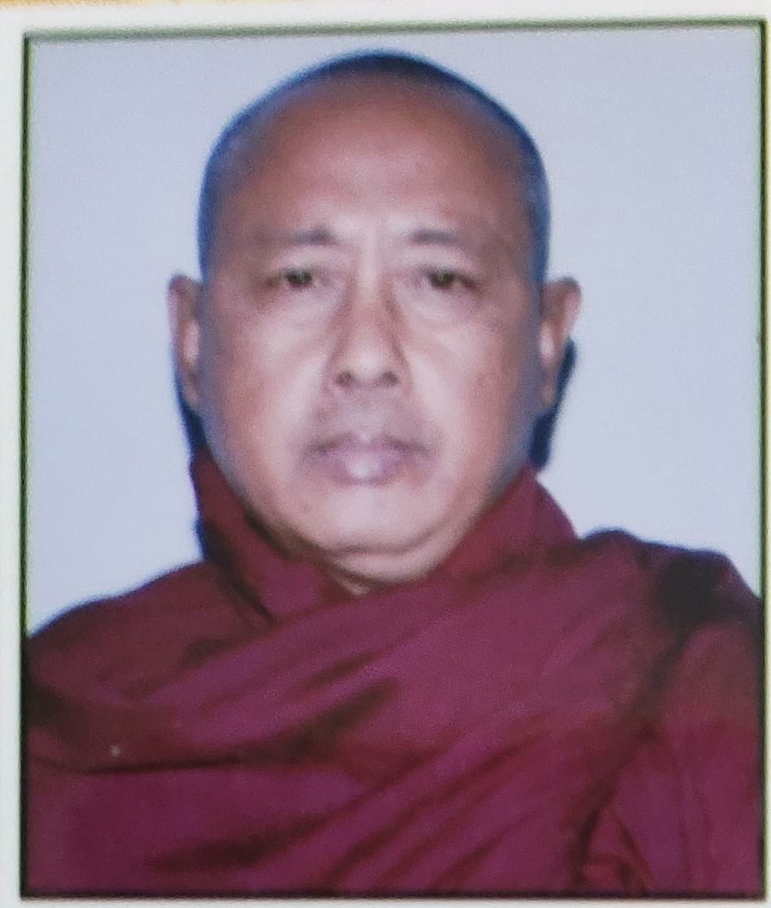
Secretary
Bhikshu Nanda Mahathera,
Myanmar Buddhist Temple, Sankisa,
District: Farrukhabad, Uttar Pradesh (India)
Contact no.: +91-9415333291

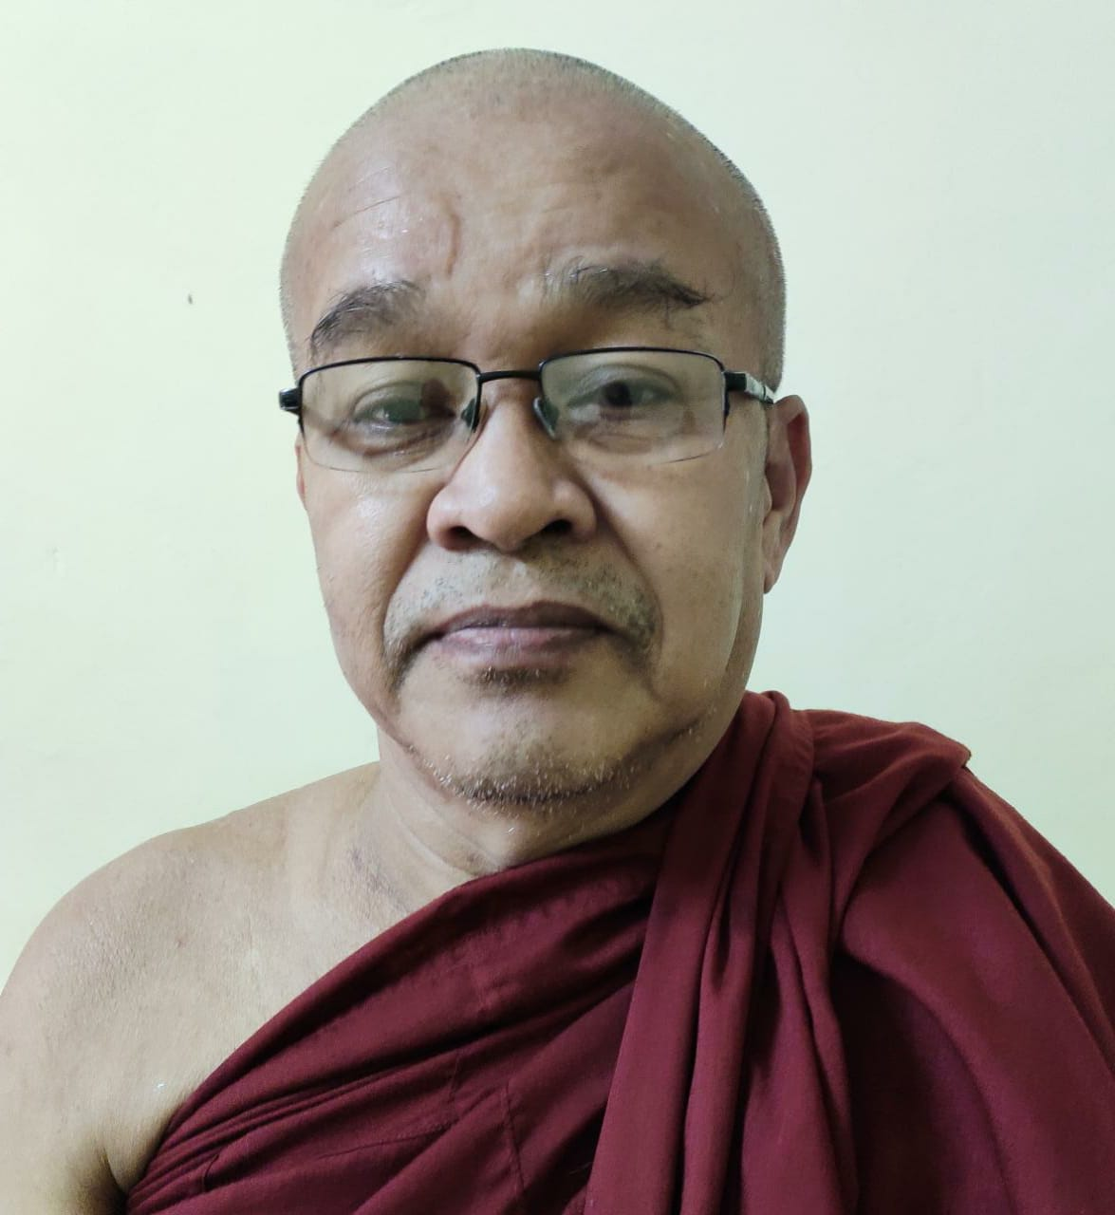
Treasurer
Bhikshu Sobhana Mahathera,
Burmese Buddha Vihara,
D/64, Sigra, Varanasi, Uttar Pradesh (India)
Contact no.: +91-9415302376

Joint Secretary
Dr. Bhikkhu Nand Ratan Thero
Monk-in-Chief,
Sri Lanka Buddha Vihara,
Near Mukutbandhan Chaitya, Kushinagar,
Post & District: Kushinagar, Uttar Pradesh (India)
Contact no.: +91-9935874061

Centres & Activities

Other Centres:
- Arya Sangharama, Sarnath, Varanasi (U.P.)
- Shakyamuni Vihar, D 64/135, Sigra ,Varanasi (U.P.)
- Chandramani Buddha Vihar, Kunserawa, Nautanawa, Maharajganj (U.P.)
- Myanmar Buddha Vihar, Sankisa, Farrukhabad (U.P.)
- Sri Lanka Buddha Vihara, Near Mukutbandhan Chaitya, Kushinagar, (U.P.)

Activities:
Kushinagar Bhikshu Sangha, Kushinagar is running the educational, social and religious activities for the welfare of humanity and all the living beings. The brief details of its activities are given below:
- Chandramani Free School, Kushinagar (U.P.)
- Bhagawan Buddha Shiksha Sansthan, Siwan (Bihar)
- Chandramani Homoeo Clinic, Kushinagar (U.P.)
- Nirvana Library, Kushinagar (U.P.)
- Buddhist Free Guest House, Kushinagar (U.P.)
- Arakanese Guest House, Kushinagar (U.P.)
- Myanmar Sima Mandir, Kushinagar (U.P.)
- Nepalese Dharmsala, Kushinagar (U.P.)
- Mahavir V.I.P. Guest House, Kushinagar (U.P.)
- Chandramani Guest House, Kushinagar (U.P.)
- U. Kittma Guest House, Kushinagar (U.P.)
- Buddha Purnima Celebrations
- International Tipitaka Chanting
- Mahaparitrana Patha Function
- Buddhist Ordination Ceremony
- Kathina Civara Dana Ceremony
- Bhikshu Mahavir Jayanti
- Dhammadiksha Ceremony
- A.B. Gyaneshwar Birthday Celebration
- Rendering necessary help to piligrims
- Restoration of Mahaparinirvana Vihar, Matha Kuanwar Temple & Ancient Stupas
Kushinagar Bhikshu Sangha, Kushinagar is running the cultural activities. The brief details of its cultural activities are given below:
- Buddha Jayanti Mela
- Guruji Jayanti (Bhikshu Chandramani Jayanti)
- Bal Divas
Kushinagar Bhikshu Sangha, Kushinagar is running the Sangha Book Agency. The activities of Sangha Book Agency are given below:
- Publication of Buddhist Books
- Ven. Chandramani Book Store

Two-Day International Seminar held in Mach 2007
Kushinagar Bhikshu Sangha, Kushinagar has organized Two-Day International Seminar on “Globalize Contributions of Buddhism: A Historical Perspective” in collaboration with the Department of Ancient History, Buddha Post Graduate College, Kushinagar and Diksha Guru Chandramani Seva Sansthan, Kushinagar on 16 & 17 March, 2007 at National Museum, Kushinagar, Uttar Pradesh (India). Kushinagar Bhikshu Sangha, Kushinagar has also published a Souvenir, International Seminar on Globalize Contributions of Buddhism: A Historical Perspective of 101 pages in the editorship of Bhikkhu Nand Ratan Thero, Alok Kumar Kashyap & Beerendra Kumar in 2007.

Publication

Books:
- Bhikshu Gyaneshwar, Bhikhsu Chandramani ka Jivan Parichay, Kushinagar: Kushinagar Bhikshu Sangha.
- Bhikshu Gyaneshwar, Majjhimādesa mein Dharma Prachar ke Anubhav (Burmese Language Book) Vol. I, Kushinagar: Kushinagar Bhikshu Sangha.
- Bhikshu Gyaneshwar, Majjhimādesa mein Dharma Prachar ke Anubhav (Burmese Language Book) Vol. II, Kushinagar: Kushinagar Bhikshu Sangha.
- Bhikshu Gyaneshwar, Majjhimādesa mein Dharma Prachar ke Anubhav (Burmese Language Book) Vol. III, Kushinagar: Kushinagar Bhikshu Sangha.
- Bhikshu Gyaneshwar, Majjhimādesa mein Dharma Prachar ke Anubhav (Burmese Language Book) Vol. IV, Kushinagar: Kushinagar Bhikshu Sangha.
- Bhikshu Gyaneshwar, Majjhimādesa mein Dharma Prachar ke Anubhav (Burmese Language Book) Vol. V, Kushinagar: Kushinagar Bhikshu Sangha.
- Dhammapada, Vol. I & II, (Ed.) Bhikshu Gyaneshwar, Kushinagar: Kushinagar Bhikshu Sangha.
- Rahul Sankrityayan, Bauddha Dharma ke Mul Siddhant, Kushinagar: Aggamahapandit Bhadant Gyaneshwar, Mantri, Kushinagar Bhikshu Sangha.

Nibbāna Bodhi Journal:
The Nibbāna Bodhi: The Research Journal of Religion, Philosophy, Culture and Social Science (An International Peer Reviewed Refereed Research Journal) is a well reputed research journal in the field of Pāli and Buddhist Studies. It is being published by Kushinagar Bhikshu Sangha, Kushinagar since 2007 continuously. The thierteen volumes of the Nibbāna Bodhi have been published till June 2019 succesfully. It is trying to spread the message of Gautam Buddha’s teachings for the welfare of society. It is UGC approved journal which consists of ISSN no. also. The more details of this journal are given below:

ISSN No.: 2229-3728
UGC Approved No.: 48596
Reg. No.: 1772

निब्बान बोधि : Nibbāna Bodhi:
The Research Journal of Religion, Philosophy, Culture and Social Science
(An International Peer Reviewed Refereed Research Journal)

Patron
Aggamahapandita Bhadant Gyaneshwar

Managing Editor
Dr. Bhikkhu Nand Ratan Thero

Editor
Dr. Gyanaditya Shakya
(Recipient of Presidential Award & Vividh Puraskar)
Assistant Professor
School of Buddhist Studies & Civilization
Gautam Buddha University, Greater Noida
Gautam Buddha Nagar-201312, Uttar Pradesh (India)
Assistant Editor
Mr. Ajay Kumar Maurya
Ph.D. Scholar
Department of Comparative Religion Philosophy
Sampurnanand Sanskrit University
Varanasi-221007, Uttar Pradesh (India)

Kushinagar Bhikshu Sangha,
Kushinagar

© Nibbāna Bodhi: The Research Journal of Religion, Philosophy, Culture and Social Science (An International Peer Reviewed Refereed Research Journal)

Published by:
Kushinagar Bhikshu Sangha
Myanmar Buddhist Temple, Buddhanagari, Kushinagar,
Post & District: Kushinagar-274403, Uttar Pradesh (India)

Patron:
Aggamahapandita Bhadant Gyaneshwar,
Myanmar Buddhist Temple, Buddhanagari, Kushinagar,
Post & District: Kushinagar-274403, Uttar Pradesh (India)

Managing Editor:
Dr. Bhikkhu Nand Ratan Thero
Monk-in-Chief,
Sri Lanka Buddha Vihara,
Near Mukutbandhan Chaitya, Kushinagar,
Post & District: Kushinagar-274403, Uttar Pradesh (India)

Editor:
Dr. Gyanaditya Shakya
Assistant Professor,
School of Buddhist Studies & Civilization,
Gautam Buddha University, Greater Noida,
Gautam Buddha Nagar-201312, Uttar Pradesh (India)

Assistant Editor:
Mr. Ajay Kumar Maurya
Ph.D. Scholar,
Department of Comparative Religion Philosophy,
Sampurnanand Sanskrit University,
Varanasi-221007, Uttar Pradesh (India)

Advisory Board:
- Ven. Dr. Ramesh Chandra Negi, Associate Professor, Department of Hetu & Adhyatm, Central Institute of Higher Tibetan Studies, Sarnath, Varanasi, Uttar Pradesh (India)
- Prof. Arvind Vikram Singh, Professor & Head, Department of Philosophy, University of Rajasthan, Jaipur, Rajasthan (India)
- Prof. Saswati Mutsuddy, Professor, Department of Pali, University of Calcutta, West Bengal (India)
- Dr. Saw Htut Sandar, Buddhist Lecturer & Advisor, Shwezedi Monastery, Yangon, and Vice-President, Asoka Health & Education Welfare Foundation, Yangon (Maynmar)
- Dr. Pradeep Kumar Das, Associate Professor, Department of Ancient History, Culture and Archaeology, Nava Nalanda Mahavihara, Nalanda, Bihar (India)

Evaluation Committee:
- Prof. Bhikshu Thic Nat Tu, Dean, Faculty of International Buddhist Studies, Vietnam Buddhist University, Ho Chi Mih City (Vietnam)
- Ven. Welivita Soratha Thero, Head, Department of Practical Buddhist Studies, Bhikshu University of Sri Lanka, New Puttalam Road, Anuradhapura (Sri Lanka)
- Prof. Koswatha, Professor, Dhammanuradha International Vipassana Centre, Anuradhapura (Sri Lanka)
- Prof. Volkmar Enslin, Director, International School of Jain Studies, Bangkok (Thailand)
- Dr. Hiroshi Sasaki, Associate Professor, Department of Social Education, University of Hiroshima, Hiroshima, Japan
- Bhikkhu Maitri Mahathero, Chairman, Nepal Bhikkhu Sangha, Kathmandu (Nepal)
- Prof. Balchandra Khandekar, Former Head, Department of Pali & Prakrit, P.W.S. Arts & Commerce College, Kamptee Road, Nagpur, Maharashtra (India)
- Prof. Har Prasad Dixit, Head, Department of Pali & Theravada, Sampurnanand Sanskrit University, Varanasi, Uttar Pradesh (India)
- Prof. Ram Nakshtra Prasad, Professor, Department of Pali, Nava Nalanda Mahavihara, Nalanda, Bihar (India)
- Prof. Subhra Barua Pavagadhi, Head, Department of Buddhist Studies, University of Delhi, Delhi (India)

Legal Advisor:
- Mr. Akhilesh Kumar Maurya, High Court Advocate, State Legal Officer, Uttar Pradesh (India)
- Mr. Manoj Kushwaha, Advocate, Diwani Kachahari, Varanasi, Uttar Pradesh (India)

Editorial Address:
Kushinagar Bhikshu Sangha
Buddhanagari, Post Office - Kushinagar
District: Kushinagar-274403, Uttar Pradesh (India)
Contact No: 9935874061, 9868060572 & 9454890262

Guidelines for Writing the Article and its Submission for the Publication in the Nibbāna Bodhi:
The Nibbāna Bodhi: The Research Journal of Religion, Philosophy, Culture and Social Science (An International Peer Reviewed Refereed Research Journal) seeks to publish quality, peer-reviewed articles in Hindi, English and Pāli languages on any aspect of Pāli literature and Buddhism. It is published twice in a year. Kindly use the Roman Script for English paper, and use Devanagari Script for Hindi paper, but both scripts may be used for the article of Pāli language. The articles as well reviews of the books should be sent to the Editor, Dr. Gyanaditya Shakya (Email: gyanaditya@gmail.com).
The Editorial Committee of the Nibbāna Bodhi Journal has decided the following points to be followed by scholars in their article. Kindly contribute your final paper as per standard given below for the uniformity of writing-style:
Title
Kindly use Title-case in font size 14. The first page should contain the title of the article, author’s name, his present position, institutional affiliation, mailing address, mobile number, and e-mail address. An abstract of the paper should consist of 100 words.
Body of the Text
Kindly use the Times New Roman font (Font size: 12, Regular) for English articles, and Walkman-Chanakya-905 font for Hindi articles (Font size: 14). The articles should not be more than 3500 words. The article should contain Introduction, Problem or Research Question, Research Methodology, Literature Review, Discussion, Conclusion, and Reference in Footnote Style (Chicago Style). Examples:
- Gandhavaṃso (Ed.) Bimalendra Kumar, Delhi: Eastern Book Linkers, 1992, p.1. (for Primary Source)
- Gyanaditya Shakya, Human Values and Buddhist Ethics, Nagpur: Sangyan Prakashan, 2020, p.1. (for Secondary Source)
- Ramesh Prasad, An Early Account of Buddhist Ordination, Dharmadoot, 2015, Vol. 81 (Managing Editor) P. Seewalee Thero, (Editor) Professor Bimalendra Kumar (Assistant Editor) Dr. Ramesh Prasad, Sarnath: Maha Bodhi Society of India, pp.31-36. (for Research Journal)
Type Setting
The manuscript of the articles typed in MS word (any version) will be accepted for the publication in the Nibbāna Bodhi Journal.
Note: Opinion expressed, facts stated or conclusion drawn in signed papers are entirely the author’s responsibility and in no case this authority is responsible for them. Papers are published on the understanding that the author has obtained necessary consent from the proper authority. The Editors have right to reject any manuscript without showing any cause.

Details of the Previous Published Issues of the Nibbāna Bodhi:
- Aggamahapandita Bhadant Gyaneshwar (Patron), Bhikkhu Nand Ratan Thero (Managing Editor), Gyanaditya Shakya (Editor), & Ajay Kumar Maurya (Assistant Editor), July-December 2020, Nibbāna-Bodhi – The Research Journal of Religion, Philosophy, Culture and Social Sciences (An International Peer Reviewed Refereed Research Journal), Vol. XVI, (ISSN No.: 2229-3728 & UGC Approved Research Journal No. 48596), Kushinagar: Kushinagar Bhikshu Sangha, pp.1-104.
- Aggamahapandita Bhadant Gyaneshwar (Patron), Bhikkhu Nand Ratan Thero (Managing Editor), Gyanaditya Shakya (Editor), & Ajay Kumar Maurya (Assistant Editor), January-June 2020, Nibbāna-Bodhi – The Research Journal of Religion, Philosophy, Culture and Social Sciences (An International Peer Reviewed Refereed Research Journal), Vol. XV, (ISSN No.: 2229-3728 & UGC Approved Research Journal No. 48596), Kushinagar: Kushinagar Bhikshu Sangha, pp.1-96.
- Aggamahapandita Bhadant Gyaneshwar (Patron), Bhikkhu Nand Ratan Thero (Managing Editor), Gyanaditya Shakya (Editor), & Ajay Kumar Maurya (Assistant Editor), July-December 2019, Nibbāna-Bodhi – The Research Journal of Religion, Philosophy, Culture and Social Sciences (An International Peer Reviewed Refereed Research Journal), Vol. XIII, (ISSN No.: 2229-3728 & UGC Approved Research Journal No. 48596), Kushinagar: Kushinagar Bhikshu Sangha, pp.1-96.
- Aggamahapandita Bhadant Gyaneshwar (Patron), Bhikkhu Nand Ratan Thero (Managing Editor), Gyanaditya Shakya (Editor), & Ajay Kumar Maurya (Assistant Editor), January-June 2019, Nibbāna-Bodhi – The Research Journal of Religion, Philosophy, Culture and Social Sciences (An International Peer Reviewed Refereed Research Journal), Vol. XIII, (ISSN No.: 2229-3728 & UGC Approved Research Journal No. 48596), Kushinagar: Kushinagar Bhikshu Sangha, pp.1-96.
- Aggamahapandita Bhadant Gyaneshwar (Chief Patron), Bhikkhu Nand Ratan Thero (Managing Editor), Gyanaditya Shakya (Editor), & Ajay Kumar Maurya (Assistant Editor), April 2018, Nibbāna-Bodhi – Research Journal of Religion, Philosophy, Culture and Social Sciences Vol. XII, Issue II (ISSN No.: 2229-3728 & UGC Approved Research Journal No. 48596), Kushinagar: Kushinagar Bhikshu Sangha, pp.1-152.
- Aggamahapandita Bhadant Gyaneshwar (Chief Patron), Gyanaditya Shakya (Editor), & Buddha Ghosh (Co-Editor), April 2018, Nibbāna-Bodhi – Research Journal of Religion, Philosophy, Culture and Social Sciences Vol. XII (ISSN No.: 2229-3728 & UGC Approved Research Journal No. 48596), Kushinagar: Kushinagar Bhikshu Sangha & Pāli Society of India, Varanasi, pp.1-184.
- Aggamahapandita Bhadant Gyaneshwar (Chief Patron), Gyanaditya Shakya (Editor), & Buddha Ghosh (Co-Editor), April 2017, Nibbāna-Bodhi – Research Journal of Religion, Philosophy, Culture and Social Sciences Vol. XI (ISSN No.: 2229-3728), Kushinagar: Kushinagar Bhikshu Sangha & Pāli Society of India, Varanasi, pp.1-142.
- Aggamahapandita Bhadant Gyaneshwar (Chief Patron), Bhikkhu Nand Ratan Thero (Editor), Gyanaditya Shakya & Buddha Ghosh (Assistant Editors), April 2016, Nibbāna-Bodhi – Research Journal of Religion, Philosophy, Culture and Social Sciences Vol. X (ISSN No.: 2229-3728), Kushinagar: Kushinagar Bhikshu Sangha & Pāli Society of India, Varanasi, pp.1-112.
- Aggamahapandita Bhadant Gyaneshwar (Chief Patron), Bhikkhu Nand Ratan Thero (Editor), & Gyanaditya Shakya (Co-Editor), April 2015, Nibbāna-Bodhi – Research Journal of Religion, Philosophy, Culture and Social Sciences Vol. IX (ISSN No.: 2229-3728), Kushinagar: Kushinagar Bhikshu Sangha, pp.1-160.
- Aggamahapandita Bhadant Gyaneshwar (Chief Patron), Bhikkhu Nand Ratan Thero (Managing Editor), Bhikkhu Upanand, Bhikkhu Gyanalok, Bhikkhu Dharmapriya, Twarit Kishor Roy & Dhananjai Rai (Co-Editors), April 2014, Nibbāna-Bodhi – Research Journal of Religion, Philosophy, Culture and Social Sciences Vol. VIII Combined Issue 2012-2013 (ISSN No.: 2229-3728), Kushinagar: Kushinagar Bhikshu Sangha, pp.1-116.
- Aggamahapandita Bhadant Gyaneshwar (Chief Patron), Bhikkhu Nand Ratan Thero (Managing Editor), Trimohan Singh, Gyanaditya Shakya & Surjeet Kumar Singh (Co-Editors), May 2011, Nibbāna-Bodhi – Research Journal of Religion, Philosophy, Culture and Social Sciences Vol. VII (ISSN No.: 2229-3728), Kushinagar: Kushinagar Bhikshu Sangha, pp.1-94.
- Aggamahapandita Bhadant Gyaneshwar (Chief Editor), Bhikkhu Nand Ratan Thero, D.K. Rai, Alok Kumar Kashyap & Beerendra Kumar (Editors), Gyanaditya Shakya, Shasan Pal & G.S. Shakya (Co-Editors), May 2010, Nibbāna-Bodhi Vol. VI, Kushinagar: Kushinagar Bhikshu Sangha, pp.1-92.
- Aggamahapandita Bhadant Gyaneshwar (Chief Editor), Bhikkhu Nand Ratan Thero, D.K. Rai, Alok Kumar Kashyap & Beerendra Kumar (Editors), Surendra Pal, Rajesh Gautam, Shasan Pal & G.S. Shakya (Co-Editors), November 2009, Nibbāna-Bodhi Vol. V, Kushinagar: Kushinagar Bhikshu Sangha, pp.1-154.
- Aggamahapandita Bhadant Gyaneshwar (Chief Editor), Bhikkhu Nand Ratan Thero, D.K. Rai, Alok Kumar Kashyap & Beerendra Kumar (Editors), Surendra Pal, Rajesh Gautam, & Shasan Pal (Co-Editors), May 2009, Nibbāna-Bodhi Vol. IV, Kushinagar: Kushinagar Bhikshu Sangha, pp.1-121.
- Aggamahapandita Bhadant Gyaneshwar (Chief Editor), Bhikkhu Nand Ratan Thero, D.K. Rai, Alok Kumar Kashyap & Beerendra Kumar (Editors), Surendra Pal, Rajesh Gautam, Shasan Pal & T.K. Roy (Co-Editors), November 2008, Nibbāna-Bodhi Vol. III, Kushinagar: Kushinagar Bhikshu Sangha, pp.1-98.
- Aggamahapandita Bhadant Gyaneshwar (Chief Editor), Bhikkhu Nand Ratan Thero, Beerendra Kumar, & Alok Kumar Kashyap (Editors), Dhananjai Rai, Surendra Pal, & Shasan Pal Bauddha (Co-Editors), November 2007, Nibbāna-Bodhi Vol. II, Kushinagar: Kushinagar Bhikshu Sangha, pp.1-92.
- Aggamahapandita Bhadant Gyaneshwar (Chief Editor), Bhikkhu Nand Ratan Thero, Beerendra Kumar, Alok Kumar Kashyap, & Bhikkhu Chandima (Editors), Rahul Raj, Dhananjai Rai, Surendra Pal, & Shasan Pal Bauddha (Co-Editors), May 2007, Nibbāna-Bodhi Vol. I, Kushinagar: Kushinagar Bhikshu Sangha, pp.1-112.

Publication of Souvenir:
Aggamahapandita Bhadant Gyaneshwar (Chief Patron), Bhikkhu Nand Ratan Thero, Alok Kumar Kashyap & Beerendra Kumar (Editors), March 2007, Souvenir, International Seminar on Globalize Contributions of Buddhism: A Historical Perspective, Kushinagar: Kushinagar Bhikshu Sangha, pp.1-101.

Contact us

Kushinagar Bhikshu Sangha
Myanmar Buddhist Temple, Buddhanagari, Kushinagar,
Post & District: Kushinagar-274403, Uttar Pradesh (India)
Email: kushinagarbhikshusangh@gmail.com
Contact no.: +91-9794625059, 9455044309 & 9935874061

Designed by: Mukul Rai, GBU

Gallery

Format: http://www.mbsiindia.org/

